Please join the EWB-USA RTP Professional Chapter as we host our Fourth Annual Nicaragua Night on November 14th, 2013. The night will include dinner, drinks, entertainment, socializing and a chance to learn more about our project in Nicaragua. There will also be a silent auction and raffle for guests. All proceeds from this event go directly towards funding our chapter’s projects and our upcoming implementation trip. Attached is a flier with the details of the event. To register for the event please visit [4thnicanight.eventbrite.com](http://4thnicanight.eventbrite.com). For more information on the group and our project, please visit <http://rtpewb.com/>.

Thank you! And we hope to see you there!

“Your Name”

EWB-USA RTP Professional Chapter Member

www.rtpewb.com

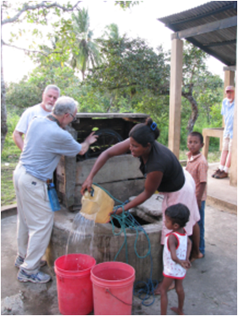

EWB-USA is a non-profit humanitarian organization dedicated to partnering with developing communities around the world. We provide engineering services through our volunteer chapter members to implement the infrastructure necessary to meet basic human needs. Through our sustainable engineering projects, we strive to improve the quality of life in the communities we serve. Thousands of members in more than 225 university and professional chapters work to support these efforts.